|  |  |  |  |  |  |
| --- | --- | --- | --- | --- | --- |
| Date | 7-Dec-22 | | | Tester Name | Andrew McLaughlin |
| Environment | Penfax - Test | | | Login used |  |
| Operating System | Windows | Version: | Update: | | |
| Software Used | Edge | Version: | Update: | | |
| Select Software | Version: | Update: | | |
| Release version | 22.4.1 | | | | |
| Title | Membership Statistics - Ad-hoc Batch | | | | |
| Test Type | Regression | | | | |
| Test Scenario | Membership Statistics - Ad-hoc Batch | | | | |
|  |  | | | | |
| Expected Results |  | | | | |
| Pass/Fail | Pass | | | JIRA# | N/A |

Describe your steps with screenshots:

Add a Bath Process for Membership Statistics, use a start time after work hours so as to not affect system performance while at work, enter today for the Calculation Date, and hit Save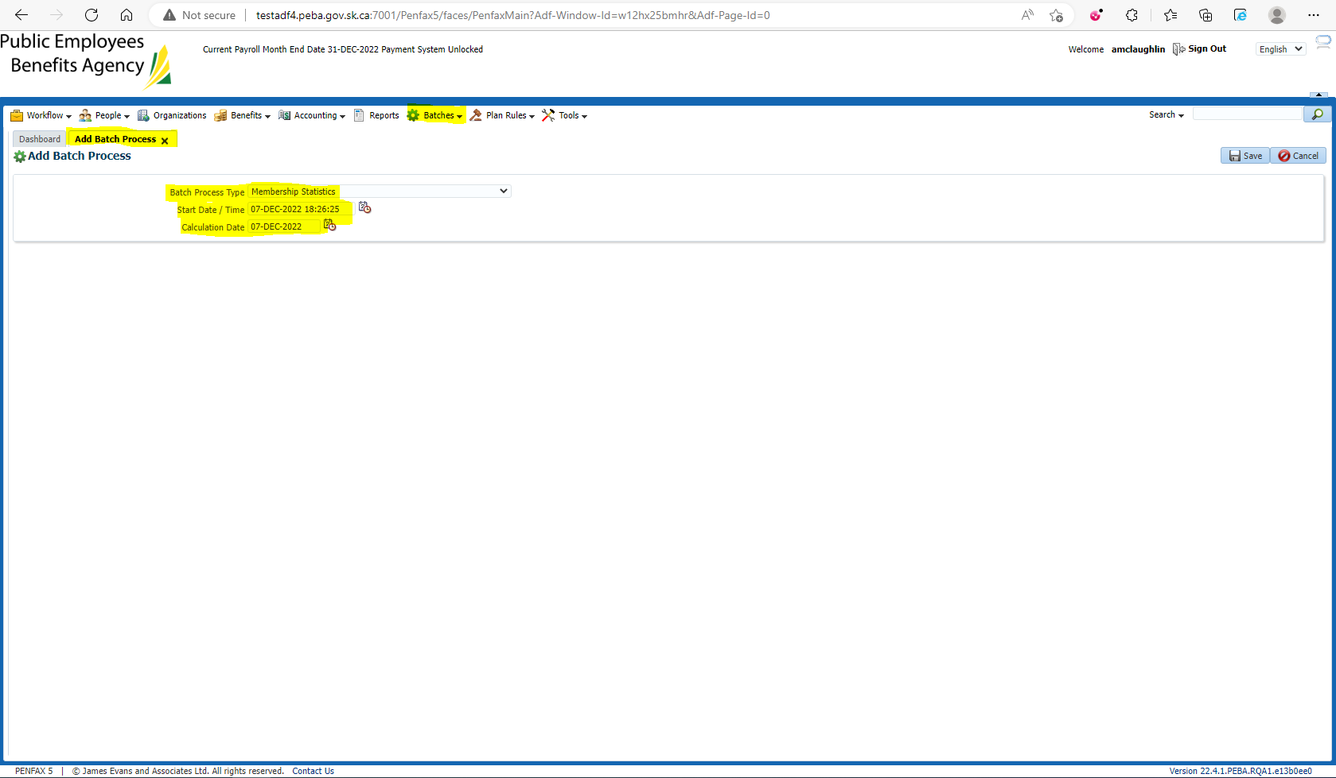

Search the batch and compare runtimes against previous batches to measure any drops in performance. Open our batch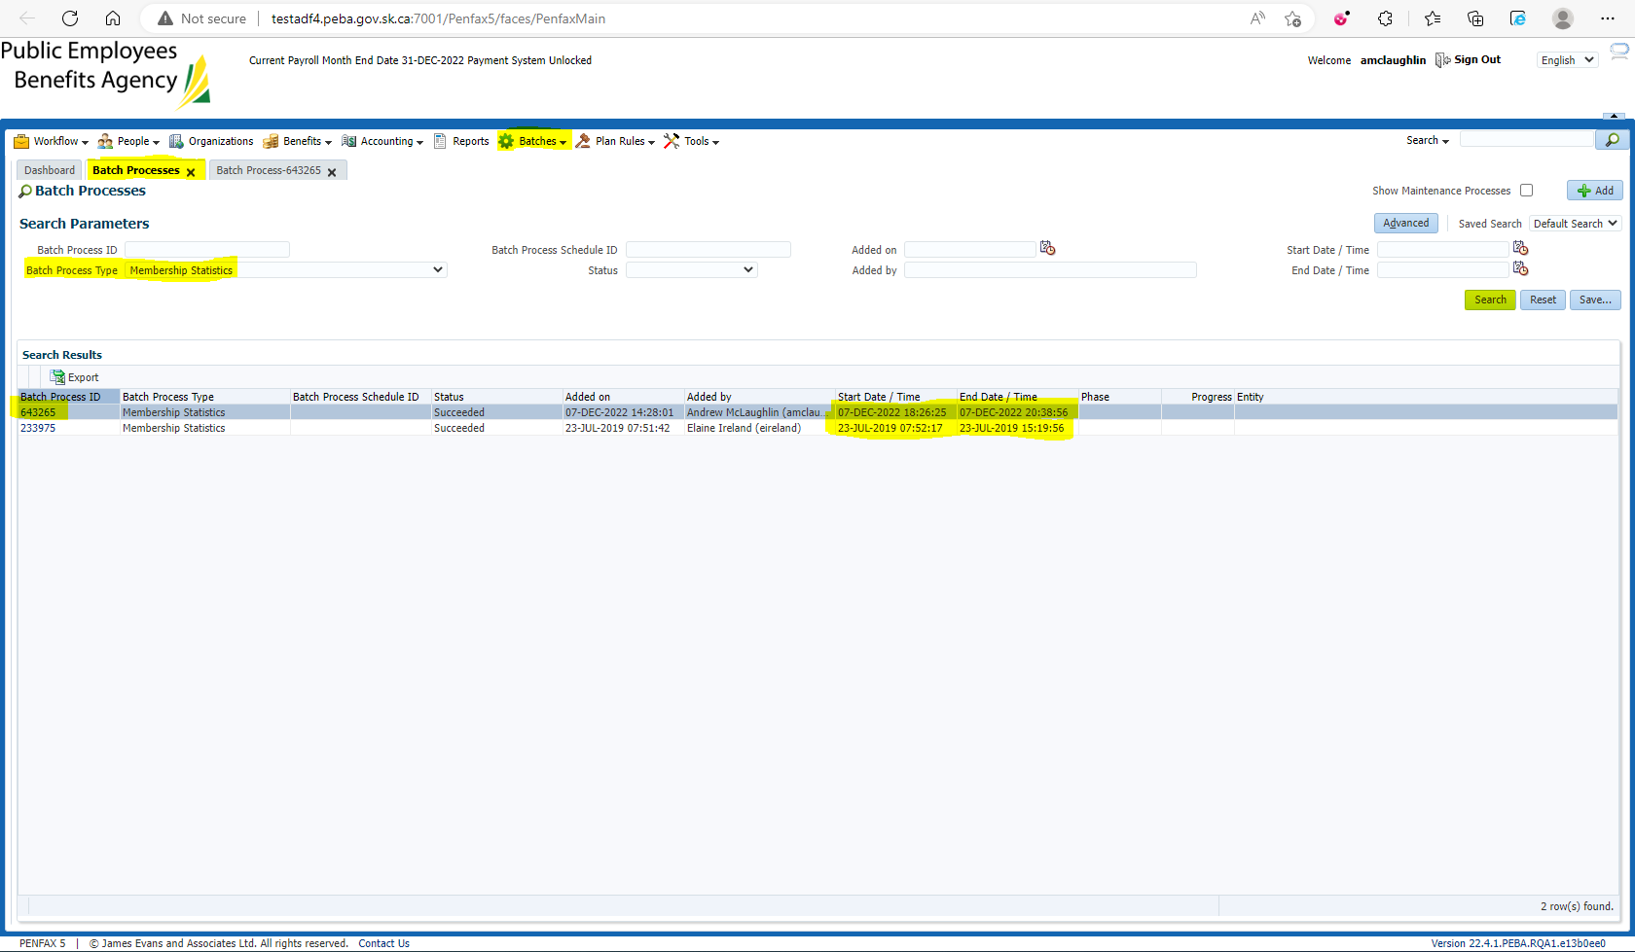

Ensure the .csv files have been created for the different member types (Active~/Deferred~)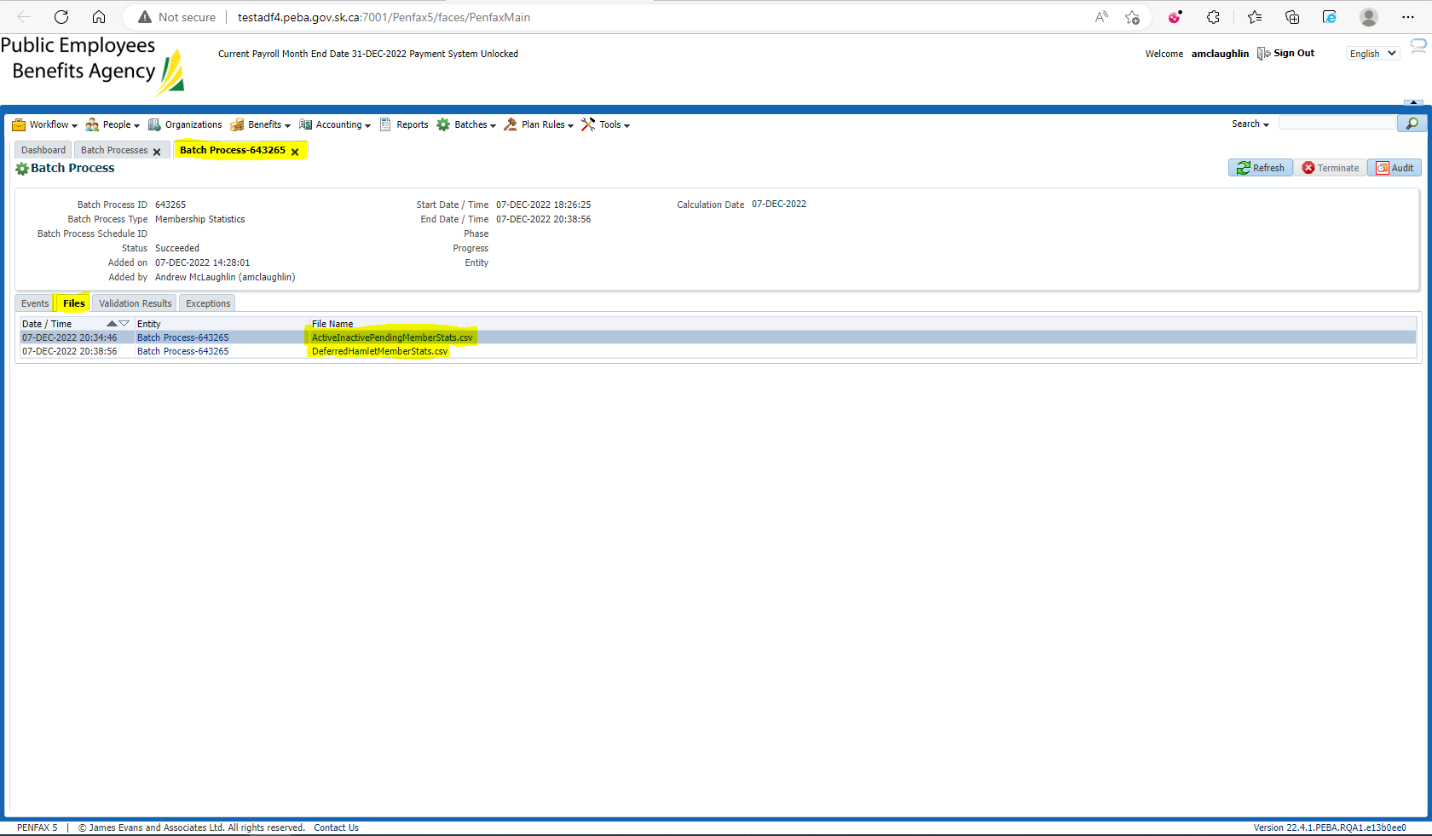

Note and compare the total amount of lines for Active/Inactive/Pending against PENFAX member search (16329 minus 1 for title line =16328) 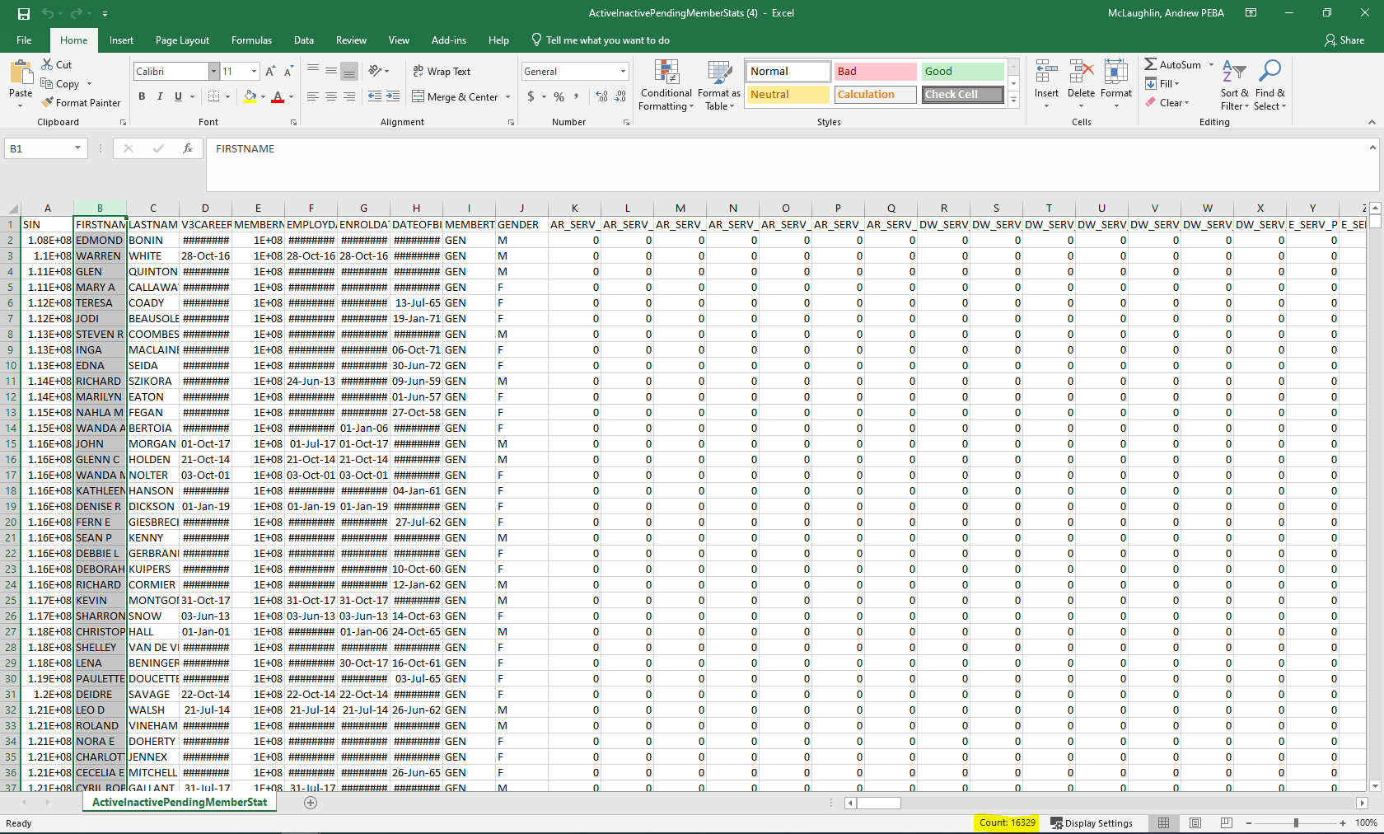

Active Members in MEPP (15181) 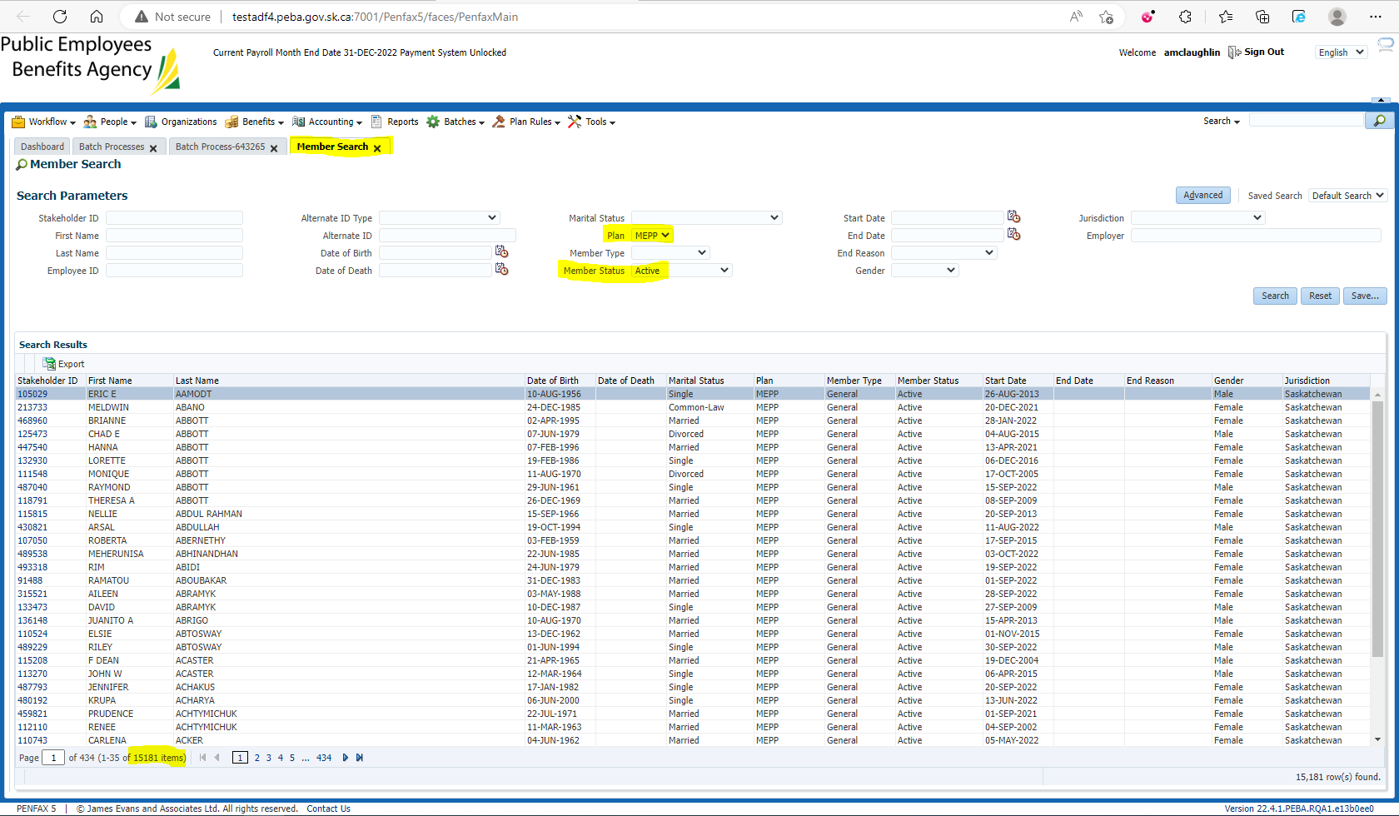

Inactive Members in MEPP (1054) 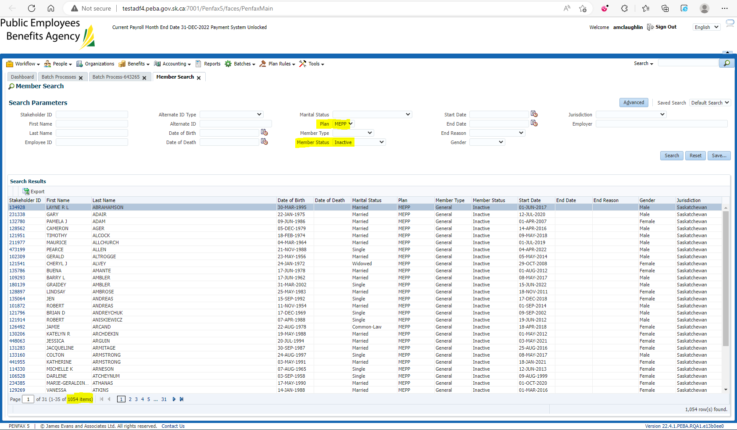

Pending Members in MEPP (93) 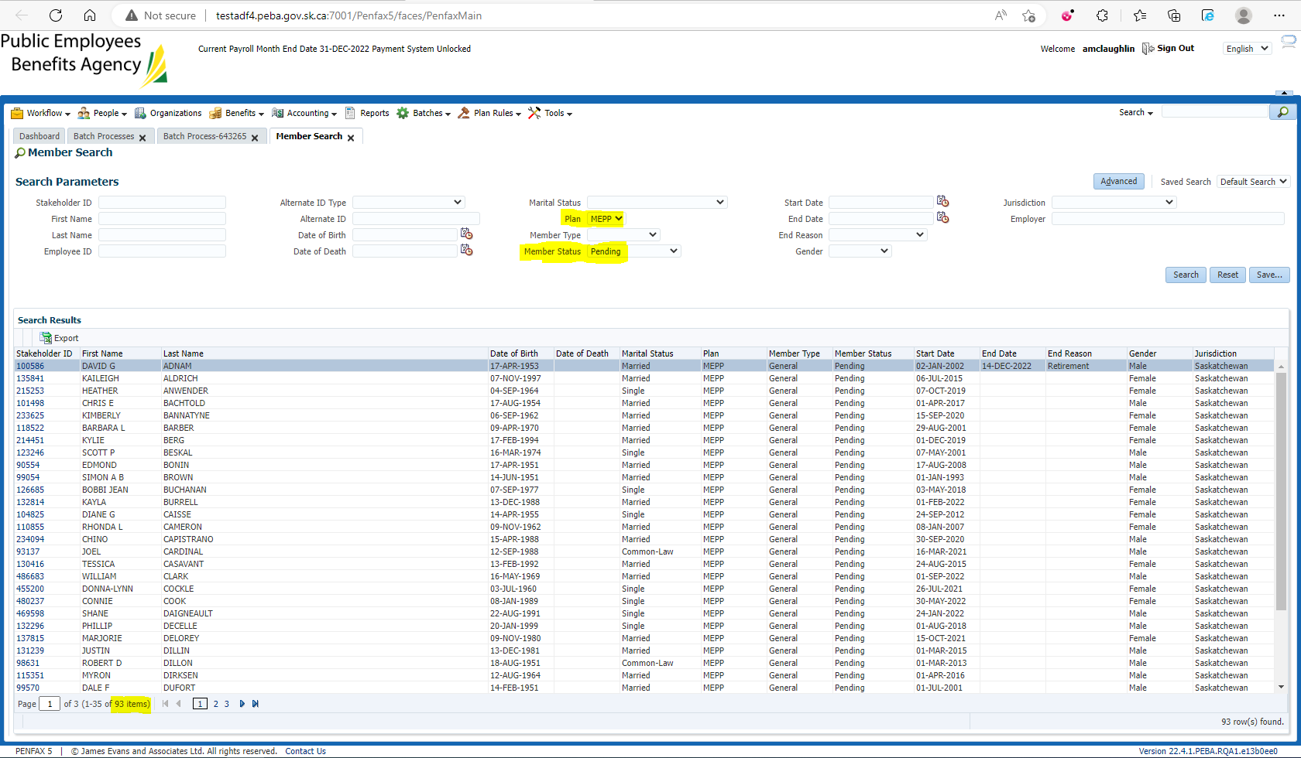

Total members = 15181 + 1054 + 93 = 16328 members

Note and compare the total amount of lines for Deferred/Hamlet against PENFAX member search (3949 minus 1 for the heading line = 3948) 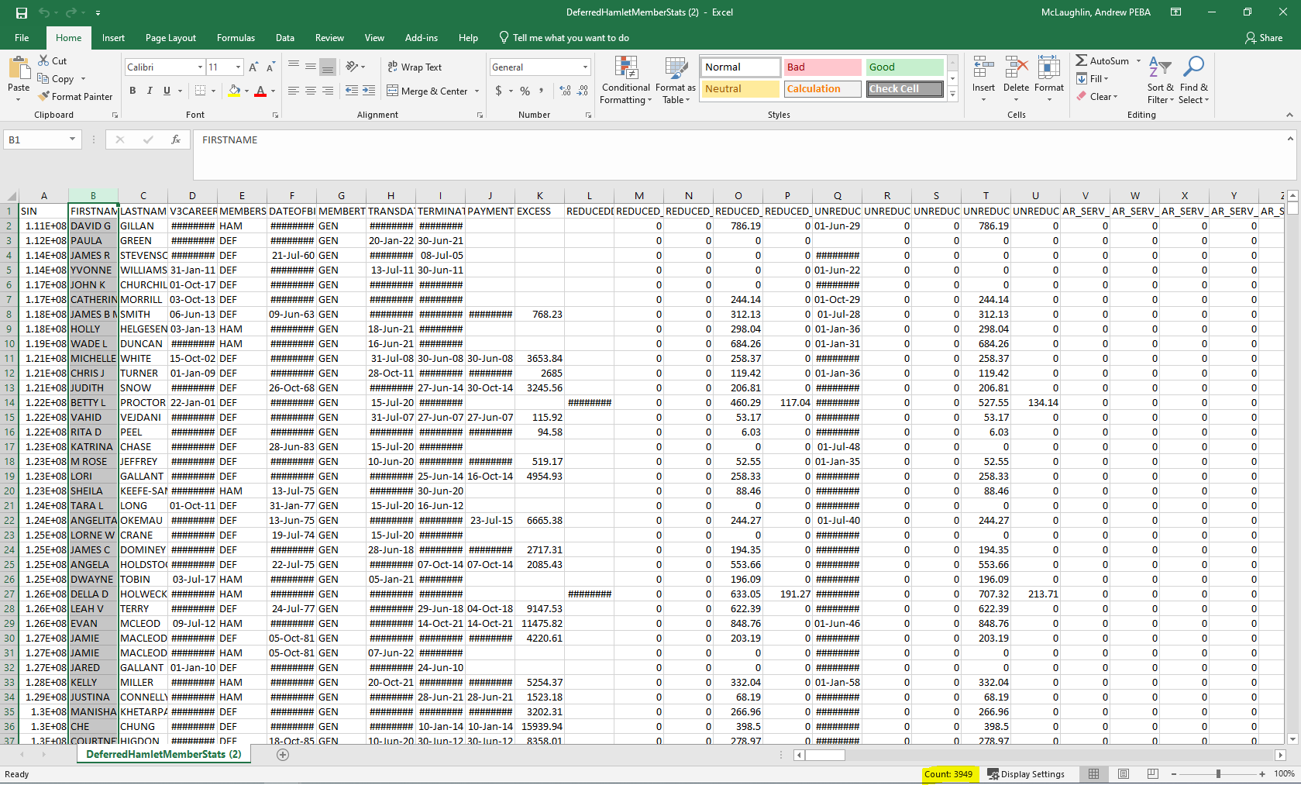

Deferred Members in MEPP (2524) 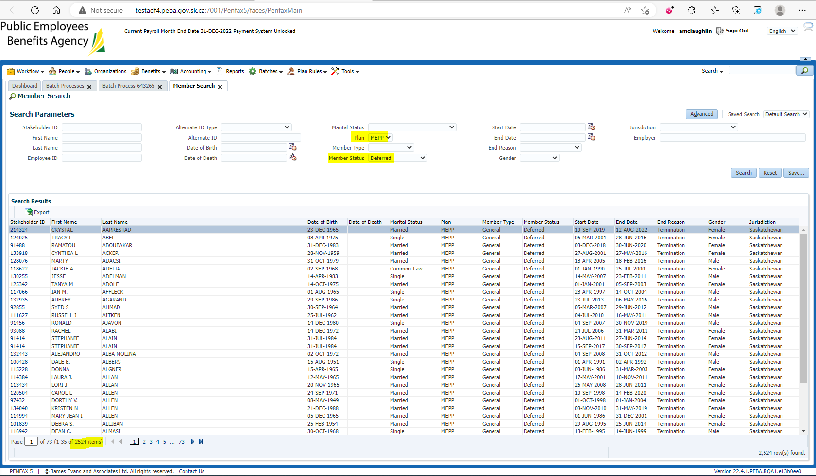

Hamlet members in MEPP (1424) 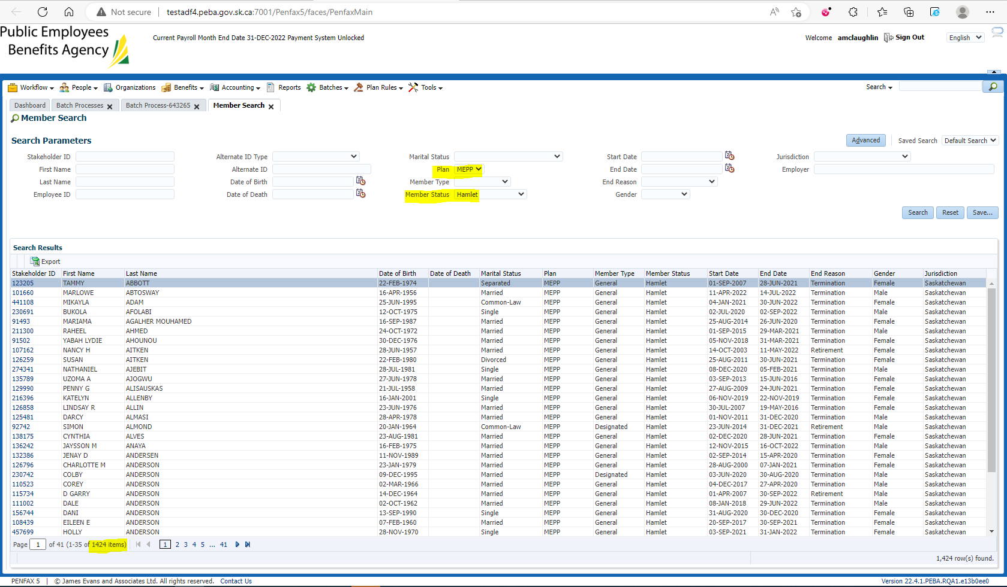

2524 + 1424 = 3948 members